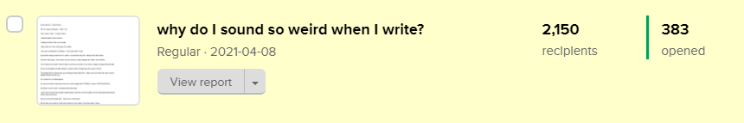
383 people opened this email: https://preview.mailerlite.com/v6b1k9

------------------------------------------------------------------------------------------

Headline: why do I sound so weird when I write?
———————————————-
{&name},

If you ask me - I don’t know.

Oh! On second thought - I think I do.

Once upon a time - in high school,

I hated english essay classes.

I always felt like a fish out of water.

I didn’t get an F but I didn’t get an A either.

I was just somewhere in between - if you get what I mean.

My teacher always wanted us to write in a particular way but I always had other ideas.

In front of the class - she’d even use my work as a bad example for others not to follow.

This method my teacher shoved down my throat messed me up when I began writing professionally.

It took me sleepless candle nights to unlearn what I thought was the way to do ME.

That might be the reason why your writing sounds weird too - when you try to write the voice of your English teacher jumps out.

Or a sales bot or Shakespeare.

It’s not your fault it’s because most of us were taught that ‘FORMAL’ means ‘PROFESSIONAL’.

And that’s not the case in entrepreneurship today.

I can’t wait to share this writing transformation with the current students of the Storywriting Bootcamp which starts tomorrow.

If you’re one of the lucky few - see you in a few hours.

By the way, you need to mute some voices in your head. You know what I mean.

Lamide.

